|  |  |  |  |
| --- | --- | --- | --- |
| Version | Change | Author | Date |
| 0 | Added ChangeLog | Peter | 22/09 |
| 1 | Added summary of rich picture for interview | Cecilie | 07/11 |
| 2 | Added rich pictures and description for literature review picture | Peter | 08/11 |
| 3 | Added rich picture for activity, competitor analysis and formatted text. | Victoria | 08/11 |
| 4 | Reviewed | Cecilie | 09/11 |
|  |  |  |  |
|  |  |  |  |

Interview

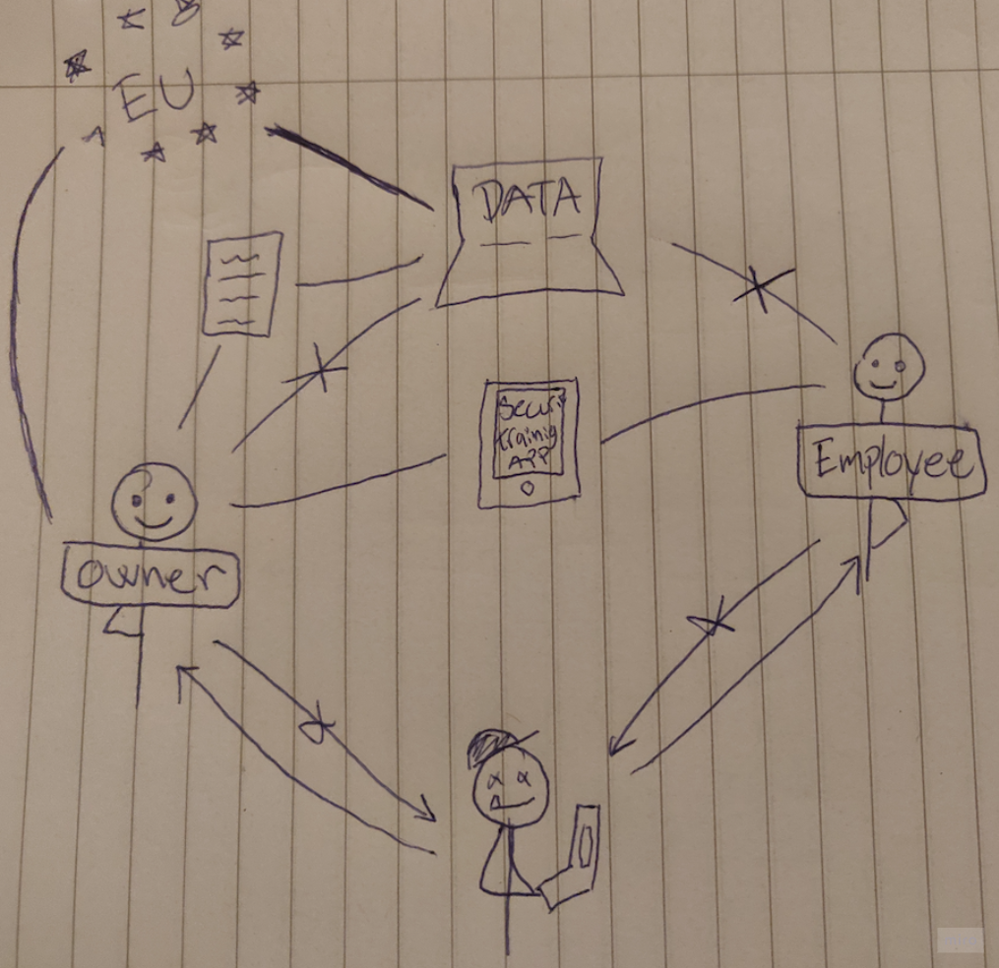

Our rich picture shows how local regulations effects how the business data should be handled.

The business owner is in this case aware of how to be compliant to such regulation and creates security policies. The business owner uses a training and education tool to make sure that they and their employees are trained in security awareness.

Someone from outside the business attempts to send a phishing email to the owner or employee to gain access to the business’ data. Luckily, the owner and employees are trained in how to handle such attacks (with help from the training and education they have received) and therefore don’t give access to the data to someone outside the business.

Literature review

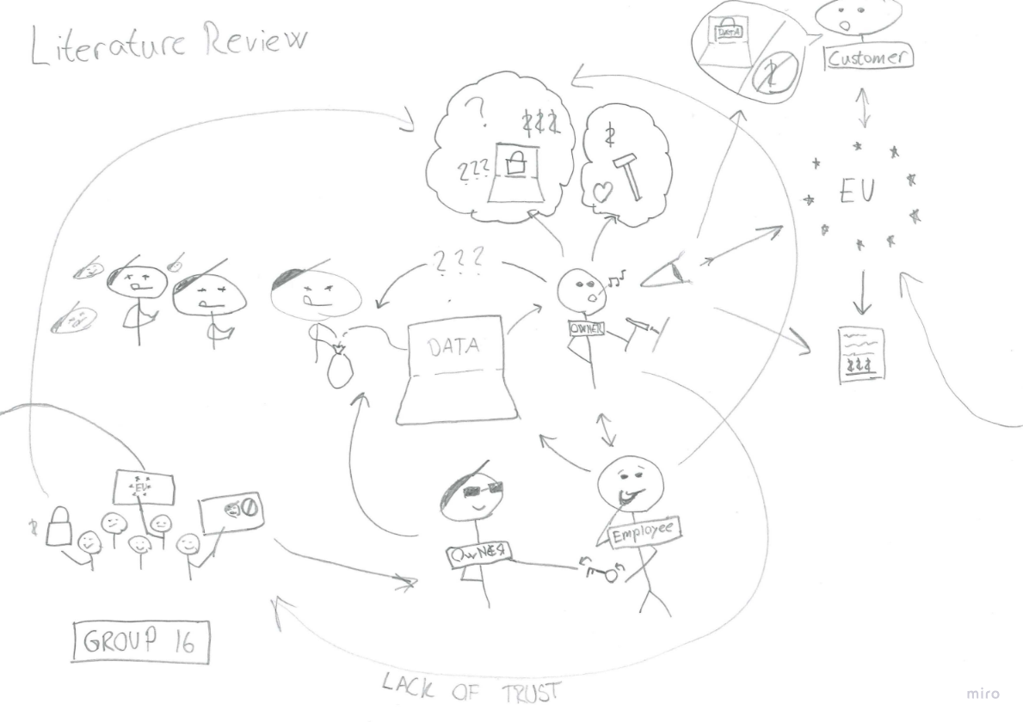

The rich picture shows how the small business’ data is being stolen by an adversary claiming to be someone else. This is a visualisation of a phishing attack in which the employee gives away access (the key) to an imposter. Meanwhile, the company owner is preoccupied with tasks and management related to the goals and workings of the business itself, while being ignorant to the security risks and theft happening right behing them. The owner is primarily concerned with complying with EU law and staying trustworthy in the minds of their customers. Our group is seen in the bottom left as solution providers to some of the discovered issues.

Competitor analysis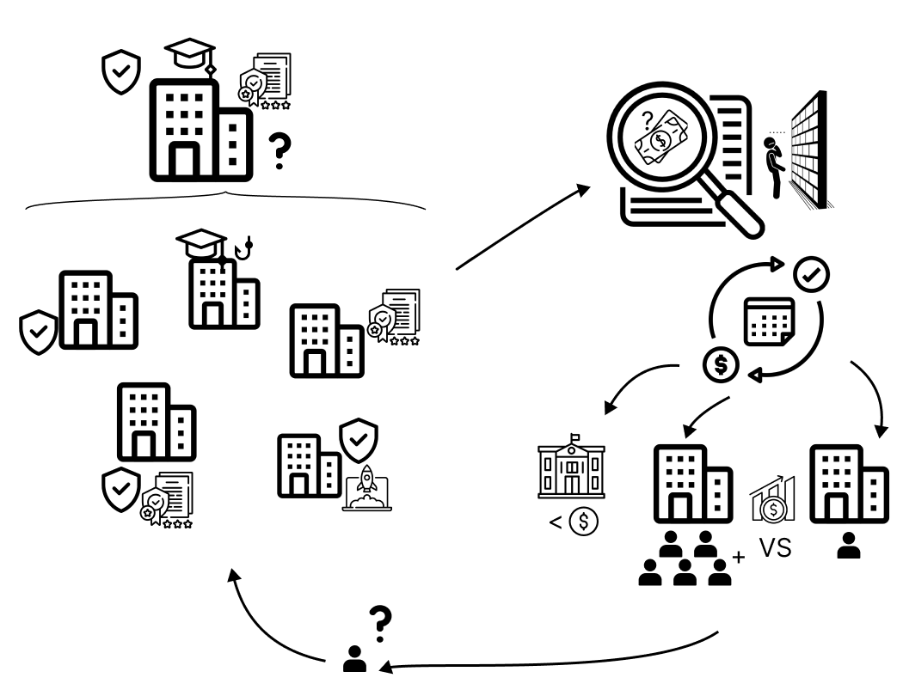

Starting from the top left, the rich picture shows how there are many kinds of companies with their own specialities. Whether it be security, compliance, education or something else. It’s rare to find a company with all three. Moving right, we found that there was a lack of transparency when finding prices for the companies’ software solution. The reason behind seemed to be that no company is the same, therefore you would have to ask them to find an individual price. Most of the solutions on the market are subscription based, sometimes cost per user, where the more users you have, are associated with lower cost per user. Larger companies have a higher advantage, this implies that it is not cost-effective for smaller companies to subscribe. Lastly, the many solutions on the market can be difficult to navigate in, especially for a small business with specific needs.